NRE 4214 – Reactor Engineering
Fall 2025

Project Report:

Two-Phase Channel Flow

Francesco Vezzola

Nuclear and Radiological Engineering
Georgia Tech
Atlanta, GA
November 30th, 2025

Introduction
This report displays the functions and logic used behind a Python program used to calculate different fluid properties and channel characteristics for a BWR with the following parameters:

Parameter | Value
# rods | 60,000
Rod length | 4.0 m
Rod outer clad diameter | 1.1 cm
Inlet flow velocity | 9 m/s
Pitch | 1.26 cm
Inlet temperature | 275°C
Axial step size for calculations | 0.01 m
Table 1 Parameters for BWR Thermo-Hydraulic calculations.
The program calculates the following properties:
- Temperature as a function of height (z), along with saturation height,
- Pressure loss due to gravity, friction and acceleration, with the last term only being calculated for the two-phase portion of the channel, each as a function of height,
- The quality and void fraction as a function of height.
Each of these properties is calculated for a channel with constant heat flux normal to the flux originating from the fuel rods and for a channel with a sinusoidal axial power distribution.

Results

Temperature Profile
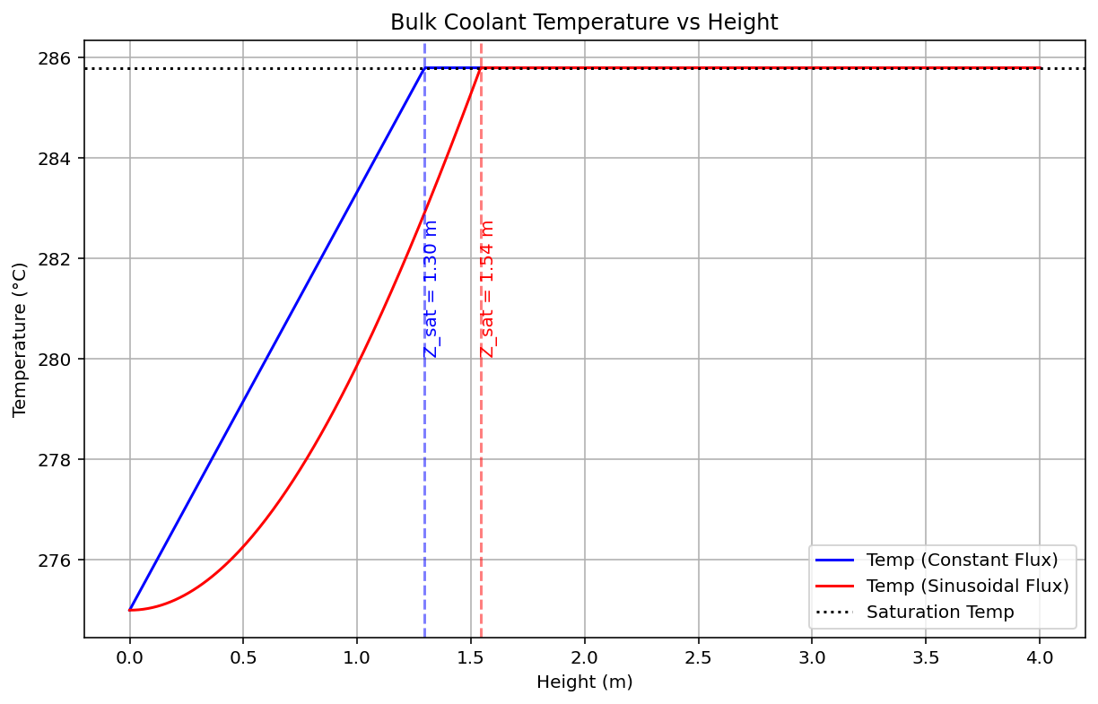
Figure 1 Vertical Temperature Profile for the Constant Heat Flux and Sinusoidal Power Distribution Cases in a BWR Sub-channel.

Pressure Drop

Constant Heat Flux
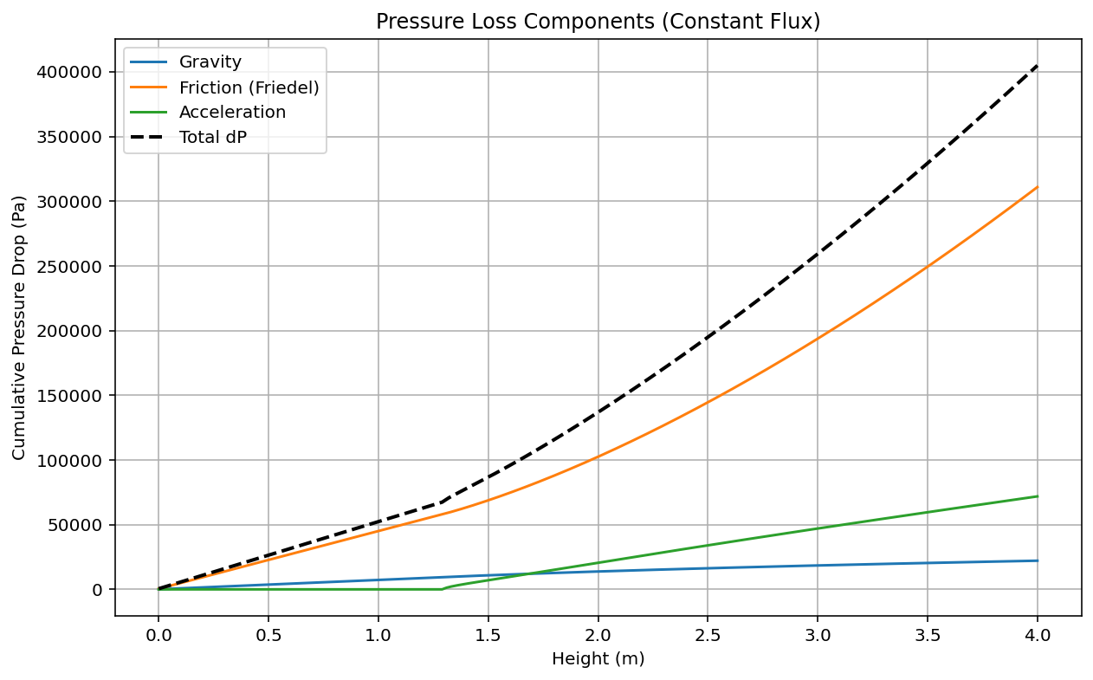
Figure 2 Vertical Total, Friction, Acceleration and Gravity Induced Pressure Losses for the Constant Heat Flux Case in a BWR Sub-channel.

Sinusoidal Power Distribution
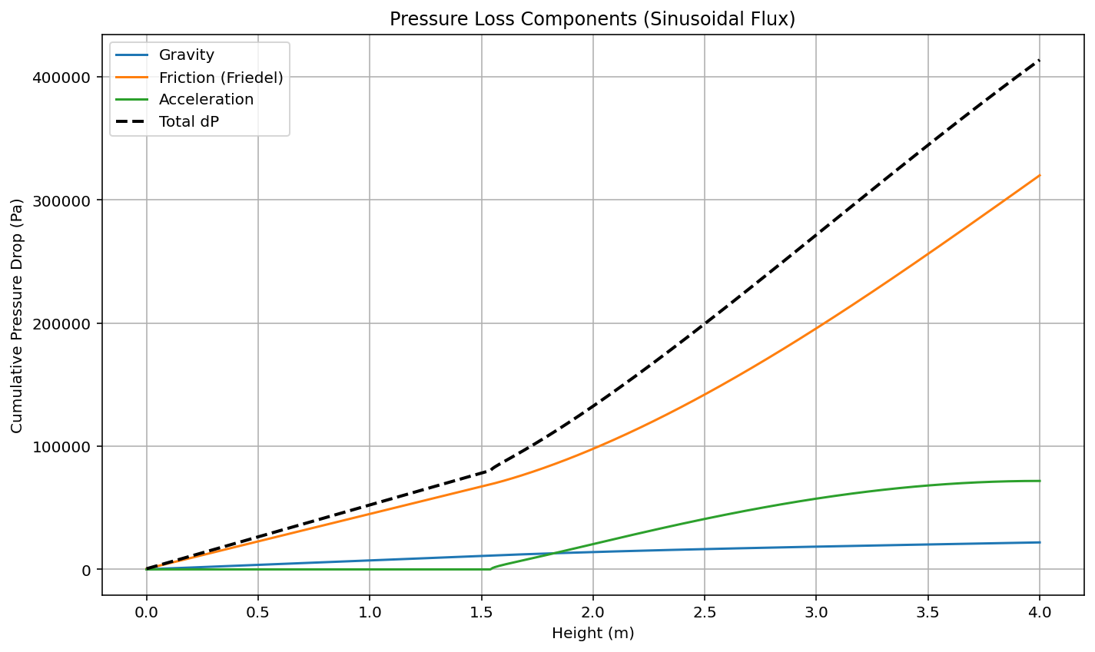
Figure 3 Vertical Total, Friction, Acceleration and Gravity Induced Pressure Losses for the Sinusoidal Power Distribution Case in a BWR Sub-channel

Axial Void-Fraction and Quality
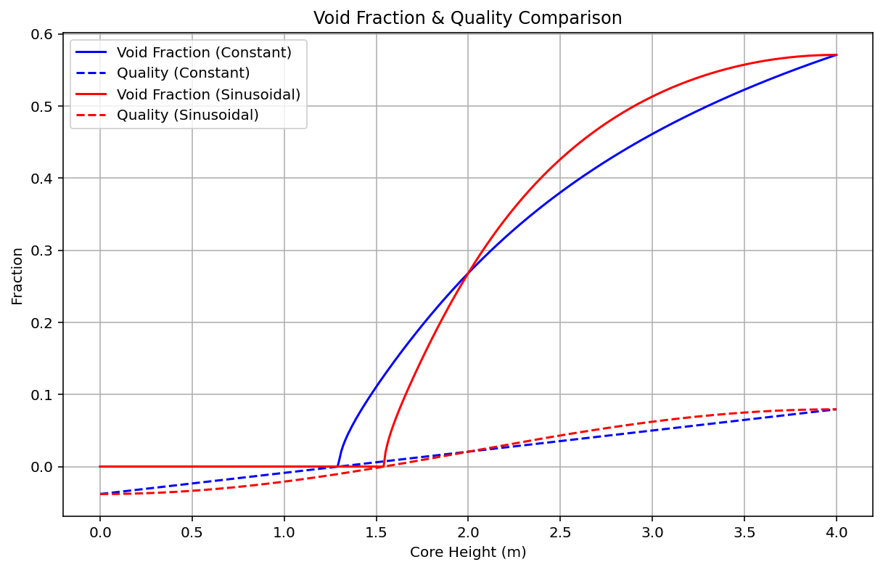
Figure 4 Void Fraction and Quality as a Function of Height

Dry-out Conditions
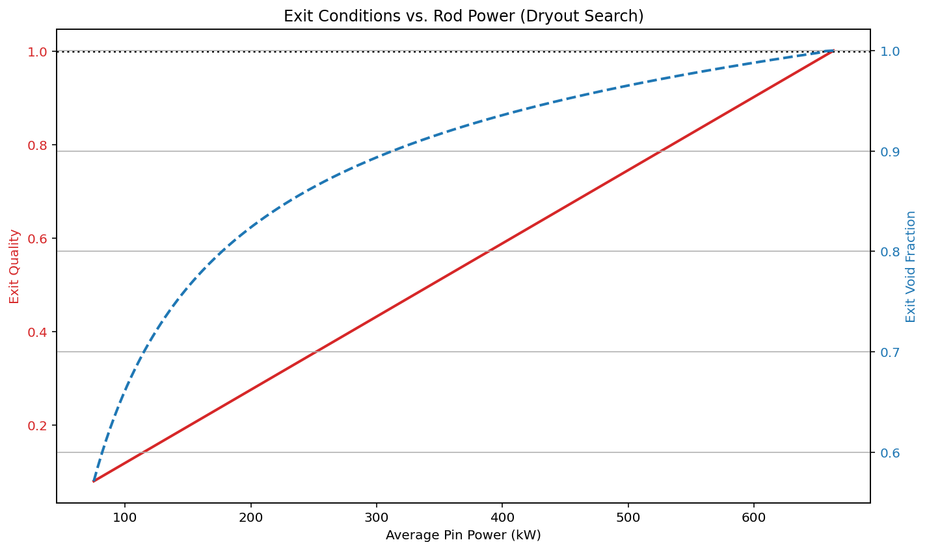
Figure 5 Exit quality as a Function of a BWR Average Fuel Rod Power Output.
The conditions for dry-out were found to be 39800 MWt total power output for the reactor, with an average pin power output of 663.33kW. It was assumed that dry-out happened when the exit quality reaches 1.

Functions and Correlations
To explain the functionality of the program, each function will be listed and each correlation and formulas explained for each function. The correlations and steps to integrate physics into code were mainly based on Todreas & Kazimi’s book Nuclear Systems Volume 1, Thermal Hydraulic Fundamentals. Citations of Book formulas will cite the book by using T&K followed by the formula number used in the book for briefness.

get_friction_factor_cheng_todreas_bundle
This function calculates the friction factor for a rod bundle in a square array using Todreas & Kazimi bundle friction coefficient formula:
$$\begin{aligned}C_{bT}^{'}=D_{eb}^{'}{\left[ \sum_{i=1}^{3}{Si{\left(\frac{D_{ei}^{'}}{D_{eb}^{'}}\right)}^{\frac{n}{n-2}}{\left(\frac{C_{fi}^{'}}{D_{ei}^{'}}\right)}^{\frac{1}{n-2}}} \right]}^{n-2}\#\left(T\&K9.106\right)\end{aligned}$$
where Si is the ratio of the total flow area of subchannels of type i to the bundle flow area, while Deb and Dei are the equivalent diameters of the bundle and of the subchannel type “i,” respectively. The chose value for n was 0.20, given by the McAdams relation for turbulent flow with Re of the order of 10^5 as is in our case. The formula for calculating the CfiT coefficient used in the previous formula is given by:

$$\begin{aligned}C_{fiT}^{'}=a+b_{1}\left(\frac{P}{D}-1\right)+b_{2}{\left(\frac{P}{D}-1\right)}^{2}\#\left(T\&K9.109a\right)\end{aligned}$$
Where coefficient a, b1 and b2 are obtained from Table 9.5b of T&K for a square array of rod bundles. The final friction factor is then obtained using the formula:
$$f_{iT}≡\frac{C_{bT}^{'}}{{\left(Re_{iT}^{'}\right)}^{0.20}}$$
The chosen assembly was chosen to be a square array of 8 by 8 fuel rods, with 64 total rods, 36 internal, 24 at the edges and 4 at the corners of the assembly.

calculate_friedel_multiplier
This function is used to calculate the $ϕ_{lo}^{2}$ liquid-only one-phase corrector factor for the two-phase friction pressure drop term. The Friedel Correlation uses the following formulas to calculate this correction factor:
$$\begin{aligned}ϕ_{lo}^{2}=E+\frac{3.24 FH}{Fr^{0.0454}We^{0.035}} \#\left(T\&K11.99\right)\end{aligned}$$
The values for E, F, H, Fr and We are calculated using the formulas in chapter 11, section 11.6.3.4 pertinent to the Friedel correlation.

calculate_chexal_lellouche
This function calculates the Chexal-Lellouche correlation for void fraction and quality calculations along the height of the channel. The correlation was chosen due to the wide range applicability of it and the fact that it always predicts the void fraction within the physically allowable range. The high mass flux was another reason this correlation was picked. The iterative formula to calculate the void fraction is given by:
$$\begin{aligned}\left\{α\right\}=\frac{\left\{β\right\}}{C_{0}+\frac{V_{vj}}{j}}, \#\left(T\&K11.48\right)\end{aligned}$$

$$\begin{aligned}C_{0}=\frac{L}{\left(K_{0}+\left(1-K_{0}\right)α^{r}\right)} \#\left(T\&K11.47a\right)\end{aligned}$$
The values of Vvj, j, K0 and L are all listed in T&K Chapter 11, section 11.5.4 pertinent to the Chexal and Lellouche correlation. The volumetric flow ration β is given by the following formula:
$$\begin{aligned}\left\{β\right\}=\frac{\frac{x}{ρ_{g}}}{\frac{x}{ρ_{g}}+\frac{1-x}{ρ_{f}}} \#\left(T\&K5.60\right)\end{aligned}$$
The function is iterated using fsolve, which iterates the residual of the solution subtracted from the previous guess and estimates the 0 of the function that describes the residual.

Main Loop
The main loop first iterates through the heigh of the channel using a change in height of 0.01m. To obtain the change in enthalpy as a function of height it is possible to start with the energy balance equation, assuming that the axial heat addition is negligible:
$$\frac{∂}{∂t}\left[\left(ρ_{m}h_{m}-P\right)A_{z}\right]+\frac{∂}{∂z}\left(G_{m}h_{m}^{+}A_{z}\right)=q^{'''}+q_{w}^{''}P_{w}+\frac{G_{m}}{ρ_{m}}\left(F_{wz}^{'''}+\frac{∂P}{∂z}\right)A_{z}$$
Assuming steady state, no internal heat generation, constant flow area and negligible shear stress and normal work this equation reduces to:
$$\frac{∂}{∂z}\left(G_{m}h_{m}^{+}A_{z}\right)=q_{w}^{''}P_{w}=q_{w}^{'}$$
Where $h_{m}^{+}$ is the flow weighted enthalpy. Setting $\dot{m}=G_{m}A_{z}$ and solving for $h_{m}^{+}$ we obtain:
$$\dot{m}\frac{∂h_{m}^{+}}{∂z}=q_{w}^{''}P_{w}→h_{m}^{+}\left(z\right)=h_{in}+\frac{1}{\dot{m}}\int_{0}^{z}{q'(z)∂z}$$
Solving for the constant heat flux case we get:
$$h_{m}^{+}\left(z\right)=h_{in}+\frac{1}{\dot{m}}\int_{0}^{z}{\frac{Q}{L}dz}= h_{in}+\frac{Qz}{\dot{m}L}, where Q=4500 MWt/60000$$
For the sinusoidal power distribution, we normalize the power distribution to equal Q over the entire height of the sub-channel:
$$Q=\int_{0}^{L}{q_{0}^{'}sin\left(\frac{πz}{L}\right)∂z}=\frac{q_{0}^{'}L}{π}2→q_{0}^{'}=\frac{Qπ}{2L}$$
Then solving for $h_{m}^{+}$ we get:
$$h_{m}^{+}\left(z\right)=h_{in}+\frac{1}{\dot{m}}\int_{0}^{z}{q_{0}^{'}sin\left(\frac{πz}{L}\right)dz}=h_{in}+\frac{1}{\dot{m}}\frac{Q}{2}{\left[-\cos\left(\frac{πz}{L}\right)\right]}_{0}^{z}=h_{in}+\frac{1}{\dot{m}}\frac{Q}{2}\left[1-\cos\left(\frac{πz}{L}\right)\right]$$

For the calculation of the pressure drop along the channel, we separate the components into friction, acceleration and gravity contributions to pressure losses. The pressure loss can be derived from the momentum balance equation:
$$\frac{∂}{∂t}\left(G_{m}A_{z}\right)+\frac{∂}{∂z}\left(\frac{G_{m}^{2}}{ρ_{m}^{+}}A_{z}\right)=-\frac{∂\left(PA_{z}\right)}{∂z}+P\frac{∂A_{z}}{∂z}-\int_{P_{wz}}{τ_{w}dP_{wz}}-ρ_{m}gcosθA_{Z}$$
Assuming steady state, and no change in area along the height of the channel we get:
$$\frac{∂\left(P\right)}{∂z}=-\frac{∂}{∂z}\left(\frac{G_{m}^{2}}{ρ_{m}^{+}}\right)-\frac{1}{A_{z}}\int_{P_{wz}}{τ_{w}dP_{wz}}-ρ_{m}gcosθ$$
The first term corresponds to the bulk acceleration pressure loss, the second term corresponds to the frictional pressure loss, and the last term corresponds to the gravitational pressure loss, with cos$θ$=1. The gravitational pressure loss is given by:
$${\left(\frac{∂P}{∂z}\right)}_{grav}= g(ρ_{v}α+ρ_{l}(1-α))$$
The acceleration pressure loss is given by:
$${\left(\frac{∂P}{∂z}\right)}_{acc}=\frac{∂}{∂z}\left(\frac{G_{m}^{2}}{ρ_{m}^{+}}A_{z}\right)=\frac{∂}{∂z}G_{m}^{2}\left[\frac{{\left(1-x\right)}^{2}}{(1-α)ρ_{l}}+\frac{x^{2}}{αρ_{v}}\right]$$
The frictional pressure loss is given by:
$${\left(\frac{∂P}{∂z}\right)}_{fric}=\frac{1}{A_{z}}\int_{P_{wz}}{τ_{w}dP_{wz}}≡ϕ_{lo}^{2}{\left(\frac{∂P}{∂z}\right)}_{fric}^{l}$$
where the fluid only, one-phase pressure loss is given by:
$${\left(\frac{∂P}{∂z}\right)}_{fric}^{l}=\frac{f_{lo}}{D_{e}}\left[\frac{G_{m}^{2}}{2ρ_{l}}\right]$$
The final main loop calculated the point of dry-out using steps of 100MWt. The exit quality and void fraction is calculated using the enthalpy values at the exit and the void fraction with the Chexal Lellouche correlation.

get_temperature_profile
The temperature profile is only calculated before saturation, as temperature is constant after saturation. To do this, temperature is interpolated using the known enthalpy values at the inlet and at the point of saturation.

Appendix

Python Program
import numpy as np
import matplotlib.pyplot as plt
from scipy.optimize import fsolve

# --- 1. Reactor Parameters ---
P_sys = 7.0e6 # System Pressure (Pa)
Q_thermal = 4500e6 # Total Core Power (W)
N_rods = 60000 # Number of rods
L_rod = 4.0 # Rod length (m)
D_rod = 1.1e-2 # Rod outer clad diameter (m)
v_inlet = 9.0 # Inlet flow velocity (m/s)
pitch = 1.26e-2 # Pitch (m)
T_inlet = 275.0 # Inlet temperature (C)
dz = 0.01 # Step size

# Geometry Calculations
A_flow_subchannel = (pitch**2) - (np.pi * (D_rod/2)**2)
P_wetted = np.pi * D_rod
D_hyd = 4 * A_flow_subchannel / P_wetted
D_e = D_hyd

# --- 2. Material Properties at 7.0 MPa ---
rho_f = 739.72 # Liquid density (kg/m3)
rho_g = 36.525 # Vapor density (kg/m3)
mu_f = 9.1266e-05 # Liquid viscosity (Pa.s)
mu_g = 1.8889e-05 # Vapor viscosity (Pa.s)
sigma = 0.017633 # Surface tension (N/m)
P_crit = 22.064e6 # Critical Pressure (Pa)
g_const = 9.81 # Gravity

# --- 3. Correlations (Chexal-Lellouche & Friedel) ---

# 3.1 Advanced Bundle Friction (Cheng & Todreas with Geometric Correction)
# Sources:
# Eq 9.106 (Bundle Aggregation)
# Eq 9.109a (Geometry Coefficients)
# Table 9.5b (Turbulent Coefficients)

def get_friction_factor_cheng_todreas_bundle(Re_bundle):
# --- 1. Define Geometry Parameters ---
P = 1.26 # Pitch (cm)
D = 1.10 # Diameter (cm)
P_D_ratio = P / D

# Assumption: Gap to wall is exactly P/2 (Standard symmetric assumption)

# --- 2. Calculate Hydraulic Diameters (D_e) for each type ---

# Interior Subchannel (Standard unit cell)
A_int = (P**2) - (np.pi * D**2)/4.0
Pw_int = np.pi * D
De_int = 4.0 * A_int / Pw_int

# Edge Subchannel (Rectangular: P x P/2)
# Area = Box - Half Rod
A_edge = (P * (P/2.0)) - (np.pi * D**2)/8.0
# Wetted Perimeter = Half Rod + Wall Length (P)
Pw_edge = (np.pi * D)/2.0 + P
De_edge = 4.0 * A_edge / Pw_edge

# Corner Subchannel (Square: P/2 x P/2)
# Area = Corner Box - Quarter Rod
A_corner = ((P/2.0)**2) - (np.pi * D**2)/16.0
# Wetted Perimeter = Quarter Rod + Wall Length (P/2 + P/2)
Pw_corner = (np.pi * D)/4.0 + P
De_corner = 4.0 * A_corner / Pw_corner

# --- CALCULATE TRUE BUNDLE HYDRAULIC DIAMETER ---
# Weighted sum for the whole 8x8 assembly
N_int = 36.0
N_edge = 24.0
N_corner = 4.0

# Total Flow Area of the Bundle
A_bundle_total = (N_int * A_int) + (N_edge * A_edge) + (N_corner * A_corner)

# Total Wetted Perimeter of the Bundle
Pw_bundle_total = (N_int * Pw_int) + (N_edge * Pw_edge) + (N_corner * Pw_corner)

# True Hydraulic Diameter of the Bundle
De_bundle = 4.0 * A_bundle_total / Pw_bundle_total

# ... (Continue with normalization D_prime_eb = De_bundle / D) ...

# --- 3. Calculate C' coefficients for each type (Table 9.5b) ---
val = P_D_ratio - 1.0

# Interior Coefficients
C_int = 0.1339 + 0.09059*val - 0.09926*(val**2)

# Edge Coefficients
C_edge = 0.1430 + 0.04199*val - 0.04428*(val**2)

# Corner Coefficients
C_corner = 0.1452 + 0.02681*val - 0.03411*(val**2)

# --- 4. Aggregate using Equation 9.106 ---
# C'_b = D'_eb * [ Sum ( S_i * (D'_ei / D'_eb)^(n/(2-n)) * (C'_fi / D'_ei)^(1/(n-2)) ) ]^(n-2)
# D'_ei = De_i / D (Normalized diameter)
# C'_fi = C_i (The coefficient we just calculated)

n = 0.20

# Normalize Diameters by Rod Diameter D (as per textbook convention D')
D_prime_eb = De_bundle / D
D_prime_int = De_int / D
D_prime_edge = De_edge / D
D_prime_corner = De_corner / D

# Subchannel Area Fractions (S_i) for 8x8 Assembly
S_int = 36.0 / 64.0
S_edge = 24.0 / 64.0
S_corner = 4.0 / 64.0

# Exponents for Eq 9.106
exp1 = n / (2.0 - n) # Exponent for Diameter Ratio
exp2 = 1.0 / (n - 2.0) # Exponent for C/D Ratio
exp_final = n - 2.0 # Final Exponent

# Summation Terms
term_int = S_int * ((D_prime_int/D_prime_eb)**exp1) * ((C_int/D_prime_int)**exp2)
term_edge = S_edge * ((D_prime_edge/D_prime_eb)**exp1) * ((C_edge/D_prime_edge)**exp2)
term_corner = S_corner * ((D_prime_corner/D_prime_eb)**exp1) * ((C_corner/D_prime_corner)**exp2)

sum_total = term_int + term_edge + term_corner

# Final Bundle Coefficient C'_bL (or C'_bT for turbulent)
C_bundle = D_prime_eb * (sum_total ** exp_final)

# --- 5. Final Friction Factor ---
# f = C'_bundle / Re^n
f_bundle = C_bundle * (Re_bundle**-n)

return f_bundle

# 3.2 Friedel Two-Phase Multiplier (Eq 11.99)
def calculate_friedel_multiplier(x, G, D_e):
# Homogeneous Density
rho_m = 1.0 / ( (x / rho_g) + ((1 - x) / rho_f) )

# Froude and Weber Numbers
Fr = (G**2) / (g_const * D_e * rho_m**2)
We = (G**2 * D_e) / (sigma * rho_m)

# Single-phase Friction Factors
Re_fo = (G * D_e) / mu_f
f_fo = get_friction_factor_cheng_todreas_bundle(Re_fo)

Re_go = (G * D_e) / mu_g
f_go = get_friction_factor_cheng_todreas_bundle(Re_go)

# E, F, H Terms
E = (1 - x)**2 + (x**2) * ( (rho_f * f_go) / (rho_g * f_fo) )
F = (x**0.78) * ((1 - x)**0.224)
H = (rho_f / rho_g)**0.91 * (mu_g / mu_f)**0.19 * (1 - (mu_g / mu_f))**0.7

# Safety for tiny numbers (approaching single phase)
if Fr < 1e-9 or We < 1e-9: return 1.0

phi_sq = E + (3.24 * F * H) / ( (Fr**0.0454) * (We**0.035) )
return phi_sq

# 3.3 Chexal-Lellouche
def calculate_chexal_lellouche(x_quality, G, P_sys):
if x_quality <= 0:
return 0.0
if x_quality >= 0.99:
return 1.0
j_g = (x_quality * G) / rho_g
j_f = ((1 - x_quality) * G) / rho_f
j_total = j_g + j_f

Re_g = (rho_g * j_g * D_e) / mu_g
Re_f = (rho_f * j_f * D_e) / mu_f

Re_g_val = Re_g if (Re_g > Re_f or Re_g < 0) else Re_f

# Constants
term_A1 = np.exp(max(-85, min(85, (-Re_g_val / 60000))))
A1 = 1 / (1 + term_A1)
B1 = min(0.8, A1)

D2 = 0.09144
C7 = (D2 / D_e)**0.6

if C7 < 1.0:
C8 = C7 / (1 - C7)
else:
C8 = 1000

if C7 >= 1:
C4 = 1.0
else:
C4 = 1 / (1 - np.exp(-C8))

C5 = (150 * (rho_g / rho_f))**0.5
C6 = C5 / (1 - C5)

density_ratio = rho_f / rho_g
if density_ratio >= 18:
if C5 >= 1:
C2 = 1.0
elif C6 >= 85:
C2 = 1.0
else:
C2 = 1 / (1 - np.exp(-C6))
else:
term_log = np.log(max(1.00001, density_ratio))
C2 = 0.4757 * (term_log)**0.7

D1 = 0.0381
term_c10_1 = 2 * np.exp((abs(Re_f)/350000)**0.4) - 1.75 * (abs(Re_f)**0.035) * np.exp((-abs(Re_f)/60000) * (D1/D_e)**2)
term_c10_2 = (D1/D_e)**0.1 * abs(Re_f)**0.001
C10 = term_c10_1 + term_c10_2

B2 = 1 / ((1 + 0.05 * abs(Re_f) / 350000)**0.4)

if j_f > 0 and j_g > 0:
C3 = max(0.50, 2 * np.exp(-abs(Re_f)/300000))
else:
C3 = 2 * (C10 / 2)**B2

def residual(alpha):
if alpha <= 1e-6: alpha = 1e-6
if alpha >= 0.999: alpha = 0.999

if Re_g >= 0:
C1 = (1 - alpha)**B1
else:
C1 = (1 - alpha)**0.5

C_p = abs((4 * P_crit**2) / (P_sys * (P_crit - P_sys)))

if alpha * C_p < 170:
L_n = 1 - np.exp(-alpha * C_p)
else:
L_n = 1.0

if C_p < 170:
L_d = 1 - np.exp(-C_p)
else:
L_d = 1.0

L_factor = L_n / L_d if L_d > 1e-9 else 1.0

K0 = B1 + (1 - B1) * (rho_g / rho_f)**0.25
r = (1 + 1.57 * (rho_g / rho_f)) / (1 - B1)
C0 = L_factor / (K0 + (1 - K0) * alpha**r)

term_drift = ((rho_f - rho_g) * g_const * sigma / (rho_f**2))**0.25
V_vj = 1.41 * term_drift * C1 * C2 * C3 * C4

return alpha * (C0 * j_total + V_vj) - j_g

alpha_guess = 1 / (1 + ((1-x_quality)/x_quality) * (rho_g/rho_f))
solution = fsolve(residual, alpha_guess)
return solution[0]

# --- 4. Main Calculation Loops (Thermodynamics + Void Fraction) ---
G = rho_f * v_inlet
Q_channel = Q_thermal / N_rods
m_dot = G * A_flow_subchannel
h_inlet = 1210.4e3
h_sat_f = 1267.7e3
h_sat_g = 2772.6e3
h_fg = h_sat_g - h_sat_f

z_axis = np.arange(0, L_rod + dz, dz)

# Dictionary to help automate the pressure loop later
# We will store (h, x, alpha) in these lists
cases_data = {
'Constant': {'h': [], 'x': [], 'alpha': []},
'Sinusoidal': {'h': [], 'x': [], 'alpha': []}
}

# --- A. Thermodynamics & Void Calculation Loop ---

# CASE 1: Constant Heat Flux
for z in z_axis:
h_z = h_inlet + (Q_channel / m_dot) * (z / L_rod)
x_eq = (h_z - h_sat_f) / h_fg

if x_eq <= 0:
alpha = 0.0
else:
x_in = min(x_eq, 1.0)
alpha = calculate_chexal_lellouche(x_in, G, P_sys)

cases_data['Constant']['h'].append(h_z)
cases_data['Constant']['x'].append(x_eq)
cases_data['Constant']['alpha'].append(alpha)

# CASE 2: Sinusoidal Heat Flux
for z in z_axis:
factor = (1 - np.cos(np.pi * z / L_rod)) / 2.0
h_z_sin = h_inlet + (Q_channel / m_dot) * factor
x_eq_sin = (h_z_sin - h_sat_f) / h_fg

if x_eq_sin <= 0:
alpha = 0.0
else:
x_in = min(x_eq_sin, 1.0)
alpha = calculate_chexal_lellouche(x_in, G, P_sys)

cases_data['Sinusoidal']['h'].append(h_z_sin)
cases_data['Sinusoidal']['x'].append(x_eq_sin)
cases_data['Sinusoidal']['alpha'].append(alpha)

# --- B. Pressure Drop Calculation Loop ---

pressure_results = {
'Constant': {'grav': [], 'fric': [], 'acc': [], 'total': []},
'Sinusoidal': {'grav': [], 'fric': [], 'acc': [], 'total': []}
}

for case_name in ['Constant', 'Sinusoidal']:

# Init accumulators
cum_grav = 0
cum_fric = 0
cum_acc = 0

# Init Momentum Flux Tracker
# Inlet assumption: x=0, alpha=0 -> Momentum flux = G^2/rho_f
prev_mom_flux = (G**2) / rho_f

alphas = cases_data[case_name]['alpha']
qualities = cases_data[case_name]['x']

for i in range(len(z_axis)):
alpha = alphas[i]
x_eq = qualities[i]
x_in = min(max(x_eq, 0.0), 1.0) # Clamp for property calc

# 1. Gravity: dP = rho_bulk * g * dz
rho_bulk = alpha * rho_g + (1 - alpha) * rho_f
dP_g_step = rho_bulk * g_const * dz
cum_grav += dP_g_step

# 2. Friction: dP = Phi^2 * dP_lo
# Liquid-only gradient
Re_fo = (G * D_e) / mu_f
f_fo = get_friction_factor_cheng_todreas_bundle(Re_fo)
dP_lo_step = f_fo * (G**2) / (2 * rho_f * D_e) * dz

if x_in <= 0:
phi_sq = 1.0
else:
phi_sq = calculate_friedel_multiplier(x_in, G, D_e)

dP_f_step = phi_sq * dP_lo_step
cum_fric += dP_f_step

# 3. Acceleration: dP = d(Momentum_Flux)
# 1/rho_momentum = x^2/(rho_g*alpha) + (1-x)^2/(rho_f*(1-alpha))
if x_in <= 0 or alpha <= 1e-6:
curr_mom_term = 1.0 / rho_f
else:
curr_mom_term = (x_in**2)/(rho_g * alpha) + ((1-x_in)**2)/(rho_f * (1-alpha))

curr_mom_flux = (G**2) * curr_mom_term

# dP_acc is the change in momentum flux
dP_a_step = curr_mom_flux - prev_mom_flux
prev_mom_flux = curr_mom_flux
cum_acc += dP_a_step

# Store cumulative results
pressure_results[case_name]['grav'].append(cum_grav)
pressure_results[case_name]['fric'].append(cum_fric)
pressure_results[case_name]['acc'].append(cum_acc)
pressure_results[case_name]['total'].append(cum_grav + cum_fric + cum_acc)

# --- 5. Plotting (Void/Quality & Pressure) ---

# Plot 1: Void Fraction & Quality
plt.figure(figsize=(10, 6))
plt.plot(z_axis, cases_data['Constant']['alpha'], 'b-', label='Void Fraction (Constant)')
plt.plot(z_axis, cases_data['Constant']['x'], 'b--', label='Quality (Constant)')
plt.plot(z_axis, cases_data['Sinusoidal']['alpha'], 'r-', label='Void Fraction (Sinusoidal)')
plt.plot(z_axis, cases_data['Sinusoidal']['x'], 'r--', label='Quality (Sinusoidal)')
plt.xlabel('Core Height (m)')
plt.ylabel('Fraction')
plt.title('Void Fraction & Quality Comparison')
plt.legend()
plt.grid(True)
plt.show()

# Plot 2: Pressure Losses Comparison

# Subplot 1: Constant Flux
plt.figure(figsize=(10, 6))
p_const = pressure_results['Constant']
plt.plot(z_axis, p_const['grav'], label='Gravity')
plt.plot(z_axis, p_const['fric'], label='Friction (Friedel)')
plt.plot(z_axis, p_const['acc'], label='Acceleration')
plt.plot(z_axis, p_const['total'], 'k--', linewidth=2, label='Total dP')
plt.title('Pressure Loss Components (Constant Flux)')
plt.xlabel('Height (m)')
plt.ylabel('Cumulative Pressure Drop (Pa)')
plt.legend()
plt.grid(True)

# Subplot 2: Sinusoidal Flux
plt.figure(figsize=(10, 6))
p_sin = pressure_results['Sinusoidal']
plt.plot(z_axis, p_sin['grav'], label='Gravity')
plt.plot(z_axis, p_sin['fric'], label='Friction (Friedel)')
plt.plot(z_axis, p_sin['acc'], label='Acceleration')
plt.plot(z_axis, p_sin['total'], 'k--', linewidth=2, label='Total dP')
plt.title('Pressure Loss Components (Sinusoidal Flux)')
plt.xlabel('Height (m)')
plt.ylabel('Cumulative Pressure Drop (Pa)')
plt.legend()
plt.grid(True)

plt.tight_layout()
plt.show()

# --- 6. Temperature & Saturation Height ---
T_sat = 285.8 # degrees C

def get_temperature_profile(h_profile, h_inlet, h_sat_f, T_inlet, T_sat):
temps = []
z_sat_found = None

for i, h in enumerate(h_profile):
if h < h_sat_f:
fraction = (h - h_inlet) / (h_sat_f - h_inlet)
T_val = T_inlet + fraction * (T_sat - T_inlet)
temps.append(T_val)
else:
temps.append(T_sat)
if z_sat_found is None:
z_prev = z_axis[i-1]
z_curr = z_axis[i]
h_prev = h_profile[i-1]
h_curr = h
fraction_z = (h_sat_f - h_prev) / (h_curr - h_prev)
z_sat_found = z_prev + fraction_z * (z_curr - z_prev)
return temps, z_sat_found

temps_const, z_sat_const = get_temperature_profile(cases_data['Constant']['h'], h_inlet, h_sat_f, T_inlet, T_sat)
temps_sin, z_sat_sin = get_temperature_profile(cases_data['Sinusoidal']['h'], h_inlet, h_sat_f, T_inlet, T_sat)

# Plot Temps
plt.figure(figsize=(10, 6))
plt.plot(z_axis, temps_const, 'b-', label='Temp (Constant Flux)')
plt.plot(z_axis, temps_sin, 'r-', label='Temp (Sinusoidal Flux)')
plt.axhline(y=T_sat, color='k', linestyle=':', label='Saturation Temp')

if z_sat_const:
plt.axvline(x=z_sat_const, color='b', linestyle='--', alpha=0.5)
plt.text(z_sat_const, 280, f' Z_sat = {z_sat_const:.2f} m', color='b', rotation=90)
if z_sat_sin:
plt.axvline(x=z_sat_sin, color='r', linestyle='--', alpha=0.5)
plt.text(z_sat_sin, 280, f' Z_sat = {z_sat_sin:.2f} m', color='r', rotation=90)

plt.xlabel('Height (m)')
plt.ylabel('Temperature (°C)')
plt.title('Bulk Coolant Temperature vs Height')
plt.legend()
plt.grid(True)
plt.show()

print("-" * 30)
print(f"Saturation Height (Constant): {z_sat_const:.4f} m")
print(f"Saturation Height (Sinusoidal): {z_sat_sin:.4f} m")
print("-" * 30)
print(f"Total Pressure Drop (Constant): {pressure_results['Constant']['total'][-1]/1e5:.3f} bar")
print(f"Total Pressure Drop (Sinusoidal): {pressure_results['Sinusoidal']['total'][-1]/1e5:.3f} bar")
print("-" * 30)

# --- 7. Dryout Power Search ---
print("7: DRYOUT SEARCH")
# Constants
current_power = 4500e6 # Start at nominal power
power_step = 100e6 # 100 MWt increment [cite: 21]

# Lists for Plotting
pin_powers = [] # X-axis: Average Pin Power (kW)
exit_voids = [] # Y-axis 1: Exit Void Fraction
exit_qualities = [] # Y-axis 2: Exit Quality

dryout_found = False

while not dryout_found:
# 1. Calculate Power Parameters
Q_channel = current_power / N_rods

# 2. Calculate Exit Enthalpy (Sinusoidal Profile is most limiting/realistic)
# At exit (z = L), the cosine integral factor is exactly 1.0:
# Factor = (1 - cos(pi * L/L))/2 = (1 - (-1))/2 = 1.0
# So h_exit = h_in + Q_channel / m_dot
h_exit = h_inlet + (Q_channel / m_dot)

# 3. Calculate Exit Conditions
x_exit = (h_exit - h_sat_f) / h_fg

# Clamp for void calculation (so code doesn't crash if x > 1)
x_in = min(max(x_exit, 0.0), 1.0)

if x_in <= 0:
alpha_exit = 0.0
else:
alpha_exit = calculate_chexal_lellouche(x_in, G, P_sys)

# 4. Store Data
# Convert Pin Power to kW for cleaner plotting
pin_powers.append(Q_channel / 1000.0)
exit_qualities.append(x_exit)
exit_voids.append(alpha_exit)

# 5. Check for Dryout Condition
if x_exit >= 1.0:
dryout_found = True
print(f"Core Thermal Power: {current_power/1e6:.0f} MWt")
print(f"Average Pin Power: {Q_channel/1000.0:.2f} kW")
print(f"Exit Quality: {x_exit:.4f}")
else:
# Increment and continue
current_power += power_step

# Safety break to prevent infinite loop if physics fail
if current_power > 100000e6:
print("Loop stopped: Power exceeded 100,000 MWt without dryout.")
break

# --- Plotting Task 7 ---
fig, ax1 = plt.subplots(figsize=(10, 6))

color = 'tab:red'
ax1.set_xlabel('Average Pin Power (kW)')
ax1.set_ylabel('Exit Quality', color=color)
ax1.plot(pin_powers, exit_qualities, color=color, linewidth=2, label='Exit Quality')
ax1.tick_params(axis='y', labelcolor=color)
ax1.axhline(y=1.0, color='k', linestyle=':', label='Dryout Limit (x=1)')

ax2 = ax1.twinx() # instantiate a second axes that shares the same x-axis
color = 'tab:blue'
ax2.set_ylabel('Exit Void Fraction', color=color) # we already handled the x-label with ax1
ax2.plot(pin_powers, exit_voids, color=color, linewidth=2, linestyle='--', label='Exit Void Fraction')
ax2.tick_params(axis='y', labelcolor=color)

plt.title('Exit Conditions vs. Rod Power (Dryout Search)')
fig.tight_layout() # otherwise the right y-label is slightly clipped
plt.grid(True)
plt.show()

